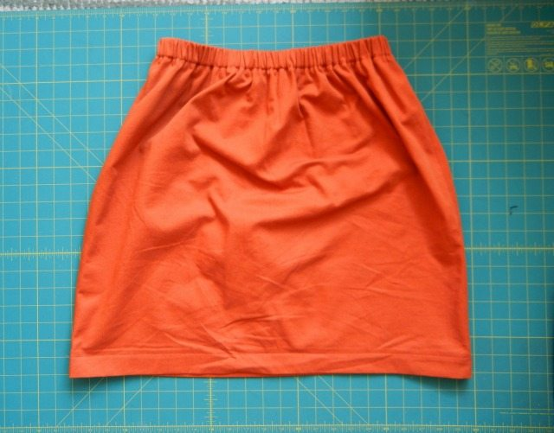
Simple Skirt Pattern

Measurements you need:
1. Waist measurement in inches
2. Hip measurement in inches
3. Desired Finished length of skirt (in inches)
from waist to finished hem.

Fabric/Elastic:
Need 100% cotton - not thin or “see-through” (amount to be determined below)
Be sure to pre-shrink (wash and dry) the fabric before cutting.
1” elastic the length of the waist measurement (non-roll elastic is very good)

Converting Body Measurement to Fabric Measurements
Once you have the 3 measurements above, use those numbers to figure out how large to cut the fabric.

For the width of the skirt fabric, add 10 inches to the hip measurement and divide by four.
For example, if the hip measurement is 39” add 10” to get 49” then
divide 49 by 4 = 12.25”.

For the length of the skirt fabric, add 3.5” to the Finished Length measurement.
For example, for a skirt with a desired finished length of 40 inches long add 3.5” = 43.5”

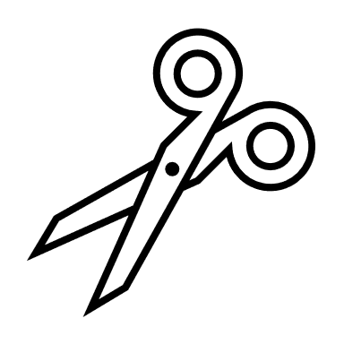
Using the dimensions you calculated, it’s time to cut!
Fold your fabric in half, with the two selvage edges together at the top.
Measure the final width number (remember from the example that it was 12.25″) from the folded edge and measure the final length number along the fold (in our example it was 43.5″).
Now, repeat! You should end up with two identical rectangles. These are the front and back of the skirt. When you open them up, each piece is 24.5” wide and 43.5” long.
Note: if your fabric is plain or the print/design permits and it is wide and long enough, it would be ok to cut one folded piece that is 24.5” and 43.5” long. When you open it up, it will be 49” wide and 43.5” long.
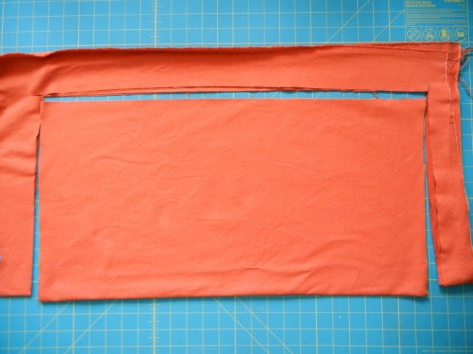
24.5” inches across the top and bottom (the length)

12.25” from the fold up (the width)

If you want to add a pocket or pockets, cut those of the desired size from the same fabric or a complimentary/matching 100% cotton fabric. Add before you stitch the waistband casing.

Sew the right sides together using 5/8” seam allowance. (You can also use a serger)
If you don’t use a serger, once you have sewn both sides, finish your seam edges.
You have 2 easy options for finishing your seam edges:
- Use pinking shears to cut the extra fabric on the outside edge of the seam.

- If you don’t have pinking shears, use your zigzag stitch to sew the edges of the seam together.

Now iron your seams down.
If you pinked your seams, press them open and flat.
If you used a zigzag stitch, press the seams to one side. Either side is fine.

Finish the bottom hem!
At the bottom of the skirt, measure and press up the edge 1/2″ to the inside of the garment.
Do this all the way around the bottom.
Then, measure and press up an additional 1″ in the same way – all the way around the bottom. Use a straight stitch to stitch the hem. The bottom hem is done!

Make and finish the waist casing!
At the top (waist) of the skirt, measure and press up the edge 1/2″ to the inside of the garment.
Do this all the way around.
Then, measure and press up an additional 1 1/2″ in the same way – all the way around.
Use a straight stitch and stitch (“top stitch”) very close to the top of the waistband. If you stitch at ¼” or more, the elastic won’t have enough room to move inside the casing. Sewing the “top stitch” gives a finished look plus it makes the waistband/elastic last longer.
Next, sew a straight stitch very close to the bottom of the casing. Again, do not stitch more than ¼” from the bottom or the elastic won’t have enough room to move inside the casing. As you sew the bottom casing, STOP and leave about a 2” opening (usually the opening is in the back).
Thread the elastic through the casing (use safety pins on each end so it won’t get “lost” in the casing).
Overlap the ends of the elastic about 1” and stitch. Use a zigzag stitch or reinforced stitching). Make at least two passes with stitching; if the elastic breaks or works loose, it will near impossible to ever fix by the girls/women.
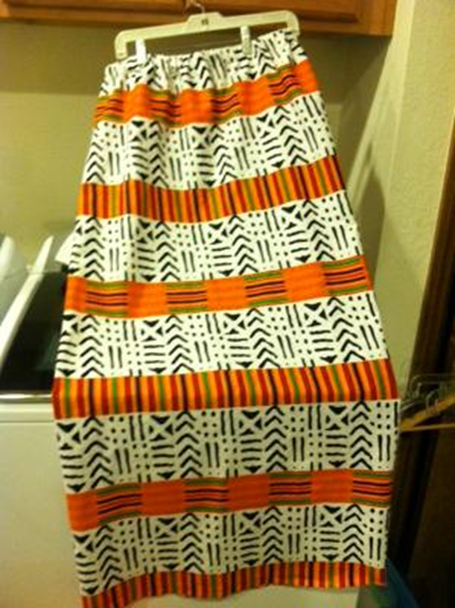
Gently pull the elastic back into the waistband and finish stitching the bottom casing. Be careful not to stitch through the elastic when sewing the casing bottom seam closed! Fluff out the waistband by gently stretching the elastic.
Finishing Up!

Trim any stray threads. The skirt is done!

Please remember to pray for the girl or lady who will receive this skirt!

If you would like, buy a new matching t-shirt and turn in with the skirt.

