

**Scottsdale Bible Church**

**Children’s Ministry**

**Volunteer Manual**

**2013-2014**

**Table of Contents**

**SECTION SUBJECT PAGE**

1. **Ministry Philosophy 1**

1. **Ministry Staff & Leaders 2**
2. **General Policies & Procedures 3 - 20**
3. Volunteer On-Boarding
4. Volunteer Roles & Responsibilities
5. Ministry Scheduler Pro (MSP)
6. Safety & Security
7. Lockdown & Evacuation
8. Reducing the Risk & Sick Child
9. Allergic Reaction
10. Restroom & Physical Contact
11. Accident/Incident Report & Discipline
12. Q & A
13. **Children’s Welcome Center 21 - 22**
14. Kidz Check & New Family Orientation
15. **Classroom Procedures 23 - 27**
16. Décor & Sanitation
17. Check In/Out
18. Room Closure Process
19. **Sunday Programming & Curriculum 28-37**
20. Programming
21. Curriculum Overview
22. Scope & Sequence
23. **AWANA 38-40**
24. **Volunteer Resources &**

**Calendar of Events 41-51**

1. Helpful Tips
2. Media Resource Center
3. Key Dates for 2012 - 2013

**Ministry Philosophy**

We have a huge responsibility to love and equip the children God puts under our care. We also understand that God has called parents to the task of being the spiritual leaders in their families. Therefore, we want to come alongside parents, not just their children, to help influence and shape the next generation of Christ-followers.

***Vision*** is to equip a generation of grace-filled, Christ-following families empowered by the Gospel of Jesus Christ.

***Mission*** is to partner with parents to win their children to Christ; build them up in their faith; and send both the child and their family out to be winners and builders among their families, friends and communities.

***Values***

* Parents are the spiritual leaders of their children
* Grace-Based Parenting: Parenting our kids like God parents His
* Connecting families in authentic relationships (small groups, mentoring, etc.)
* Children are not only the future of the Church, they are part of the Church today and can be used by God
* The Gospel not only begins, but also sustains our walk with God
* Atmosphere of love and grace throughout all of Children’s Ministry

**Children’s Ministry Staff Team**

Ryan Heath Kory Schuknecht

Pastor of Children’s Ministry Pastor of Family Ministries

[rheath@scottsdalebible.com](mailto:rheath@scottsdalebible.com) [kschuknecht@scottsdalebible.com](mailto:kschuknecht@scottsdalebible.com)

480.824.7202 480.824.8271

Erica Holmberg Susan Wood

Children’s Ministry Lead Coordinator Coordinator, Creative Programming

[eholmberg@scottsdalebible.com](mailto:eholmberg@scottsdalebible.com) [swood@scottsdalebible.com](mailto:swood@scottsdalebible.com)

480.824.7308 480.824.7247

Kelli McAnally Linda Larson

Curriculum & Enrichment Coordinator Ministry & Database Support Coordinator

[kmcanally@scottsdalebible.com](mailto:kmcanally@scottsdalebible.com) [llarson@scottsdalebible.com](mailto:llarson@scottsdalebible.com)

480.824.7212 480.824.7256

Nicole Redeske Renee Bickers

Volunteer Scheduling & Database Office & AWANA Administrative

Coordinator Coordinator

[nredeske@sbcaz.org](mailto:nredeske@sbcaz.org) [rbickers@scottsdalebible.com](mailto:rbickers@scottsdalebible.com)

480.824.7261 480.824.7220

Ruthie Smith Kelli Wert

Hospitality & Program Support Coordinator Childcare Supervisor

[rsmith@scottsdalebible.com](mailto:rsmith@scottsdalebible.com) [kwert@scottsdalebible.com](mailto:kwert@scottsdalebible.com)

480.824.288 480.824.7219

Sue Krauser Len Brommers

AWANA Commander (Volunteer) Kidz Check Coordinator

[skrauser@sbcaz.org](mailto:skrauser@sbcaz.org) [lbrommers@scottsdalebible.com](mailto:lbrommers@scottsdalebible.com)

480.824.7279 480-824-7200 (Kidz Check # 480-824-7294)

Brooke Hellestrae (Cactus Campus) Danielle Gerwin (Cactus Campus)

Children’s Ministry Coordinator Children’s Ministry Coordinator

[kmcanally@sbcaz.org](mailto:kmcanally@sbcaz.org) [kwert@scottsdalebible.com](mailto:kwert@scottsdalebible.com)

480.824.7212 480.824.7219

**Weekend Volunteer Coaches**

**Saturday 5pm** **Michelle Sarrett** – Ministry Coach [2old2fly@cox.net](mailto:2old2fly@cox.net)

**Sunday 8am *OPEN OPPORTUNITY*** *– Ministry Coach*

**Sunday 9:30am** **Kaylyn McAnally** – Building A

[km@cox.net](mailto:km@cox.net)

**Lyn Arnold** – Elementary (TreeHouse & Upper D) [arnoldremx@cox.net](mailto:arnoldremx@cox.net) (602) 689-5499

**Sunday 11:15am Katie Petersen** – Building A

[katie6579@gmail.com](mailto:katie6579@gmail.com) (480) 277-2177

**Michelle Sarrett** – Elementary (TreeHouse & Upper D) [2old2fly@cox.net](mailto:2old2fly@cox.net)

**General Policies and Procedures**

Volunteer On-Boarding page 7

Volunteer Roles & Responsibilities page 8-9

Ministry Scheduler Pro (MSP) page 10-14

Safety & Security page 15-20

Lockdown & Evacuation page 15a

Reducing the Risk & Sick Child page 15

Allergic Reaction page 16

Restroom & Physical Contact page 17

Accident/Incident Report & Discipline page 18

Safety & Security Review page 19-20

**Volunteer On-Boarding**

Each volunteer is required to complete the Volunteer On-Boarding process as identified in the chart below. All volunteers must have a current background check on file during their time of service in Children’s Ministry. Background checks expire every 3 years. You will be notified when your background check must be renewed up to 90 days prior to its expiration.

**Volunteer On-Boarding Process:**

**Meet & Greet with Ministry Coordinator**

**Completed Application is Returned to**

**Children’s Ministry**

**References and Background Check are Processed**

**After References and Background Check Clear, Volunteer is Contacted for Interview**

**Volunteer is Cleared to Serve and Entered into our Database**

**Volunteer Watches Creating a Safe Environment Video** *(This video is beingmodified)

**Volunteer Attends Safety & Security Training within 30 Days**

**Volunteer is Scheduled for In-Classroom Training & Orientation**

**Volunteer Receives Service Assignment**

**Volunteer Attends Enrichment/Training Classes** *(when available)

**Volunteer Roles & Responsibilities**

**Hospitality Team**

**Ambassadors**

Also known as greeters, these individuals are our first impression and hold the key to opening the doors to the Children’s Ministry. You may find our Ambassadors located at our gate entrances, Kidz Check, Patio Tables or anywhere a family may be led. They have the knowledge to direct our families as needed with their soft smile and warm genuine welcome as they make our families feel they belong here!

**Family Welcome Center Concierge**

Our Family Welcome Center is the central area where families will be guided to obtain information regarding our many ministry offerings. Our Concierge will also be sure to collect and process all of our guest information and direct guests to classrooms and their preferred worship service. This team begins our opportunity to build a lifelong relationship with our families.

**Volunteer Host**

It takes large team of volunteers to serve the families and children at Scottsdale Bible Church so it is very important to us we show you just how appreciated you are! We have a team specifically designated to welcome you each Sunday morning with a warm smile, snacks, beverages and once a month a warm breakfast. When not in the kitchen, our Hosts can be found in our Volunteer Studio Rooms.

**Sunday Team**

**Coach**

If you serve in a classroom or the Family Welcome Center you will find a Coach available to you at every service hour. Our Coaches are available to welcome children and assist as needed to support our Classroom Leaders and Co-Leads. Coaches may lead our pre-service briefing, which includes very important announcements and prayer. Coaches may also be used as a resource for handling discipline issues, sick children, and much more!

**Classroom Leader**

Each classroom is staffed with at least one Classroom Leader. We rely on our Classroom Leaders to ensure their class remains on schedule as they create a comfortable, fun and exciting ministry environment. Classroom Leaders must attend pre-service briefing and direct Classrooms Co-Leads.

**Classroom Co-Lead**

Classroom Co-Leads are key to successfully delivering a comfortable, fun and exciting ministry environment! They assist by helping children get adjusted upon check-in. Classroom Co-Leads may serve snacks, assist children with crafts, help tidy up their room, and assist the Leader as necessary.

**Volunteer Roles & Responsibilities**

**Office and Administration**

**Special Events Specialist** Coordinate special events for Children’s Ministry. Lead a volunteer committee and team, secure outside vendors and work with facilities and kitchen while reporting to staff leader.

**Data Entry** Assist staff team with data entry of key family information. Training is provided and weekly, regular service is preferred.

**Office Assistant** Assist staff team with various administrative tasks and projects.

**There are additional responsibilities which apply to all volunteers, they are as follows:**

* Attend New Volunteer Orientation and Safety & Security Training within 30 days of being scheduled.These trainings are required in order to serve in Children’s Ministry and offered on a quarterly basis. Additional trainings may be scheduled when needed.
* Understand and respect the call-off and substitution policy as follows:

**Call Off & Substitution Policy**

* You will receive a confirmation email no later than the Wednesday prior to your scheduled Sunday to serve. **If you receive a confirmation we are counting on your attendance.** Please follow the instructions within that confirmation email to confirm or decline your attendance no later than 12pm Thursday. This is imperative so we have enough time to find and prepare a sub for your classroom.
* Please consider the person who replaces you is leading your children and should be left in the best scenario to minister. Our children count on us to share the message of Christ and that is done most effectively when there is enough time to find a substitute and for that substitute to be prepared to minister.
* If you have a planned absence, please process in your request through Ministry Scheduler Pro (refer to pages 11-12) or you may email your coordinator ASAP. Please be advised all requests must be done in writing. In the event of an unexpected absence (i.e. family emergency or illness), please contact your coordinator via email or cell phone as instructed in your weekly confirmation.
* Please note: do ***not*** call the office phone – there is a chance that the message will not be received. If you have a last minute substitution request that is not a sickness or emergency, it is your responsibility to find your own pre-approved replacement. Should you have any questions regarding the substitution policy please contact Erica Holmberg at (480) 824-7308 or [eholmberg@sbcaz.org](mailto:eholmberg@sbcaz.org).

**Ministry Scheduler Pro (MSP) Overview**

Ministry Scheduler Pro is our volunteer scheduling software. Every week you are scheduled to serve, you will receive a confirmation email with login and confirmation instructions as well as the link to our teacher resource page.

**This is your individual login information.**

**This is the link to the web terminal. Please save this in your favorites folder.**

**Here’s the link to the web terminal from the picture above:**

[**http://www.rotundasoftware.com/ministry/sbcaz_childrensministry_earlychildhood**](http://www.rotundasoftware.com/ministry/sbcaz_childrensministry_earlychildhood)

**LOGIN INSTRUCTIONS:**

**Enter your individual username and password here.**

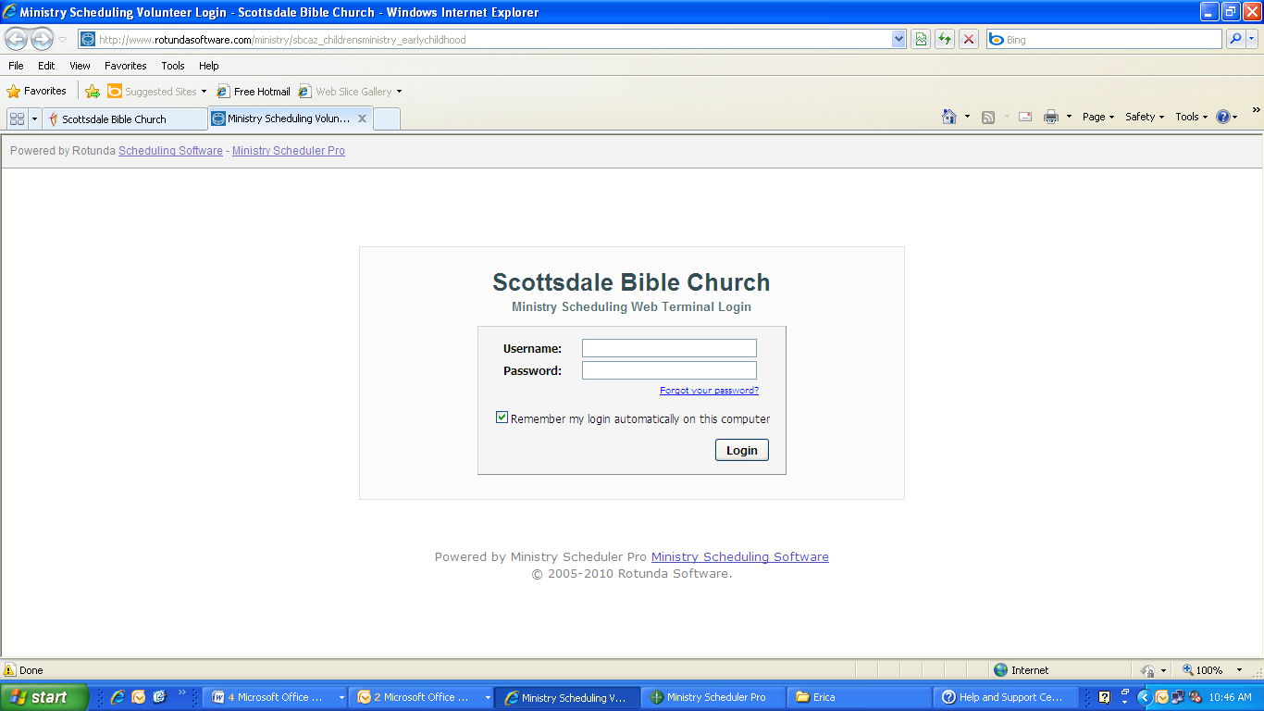

**VIEW YOUR SCHEDULE:** 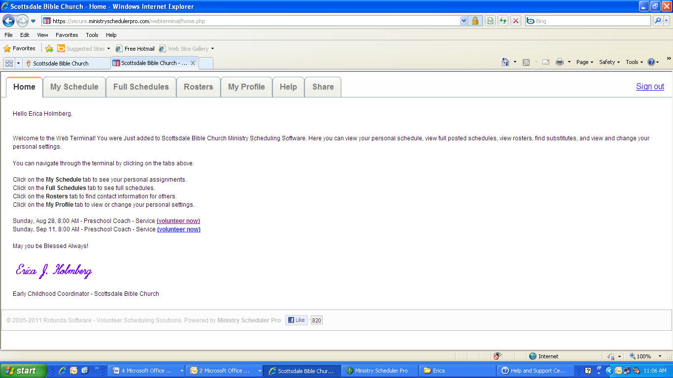

**Click on this tab to view your schedule. You will see all dates you are scheduled to serve and may request a sub from this tab.**

**REQUEST A SUB:**

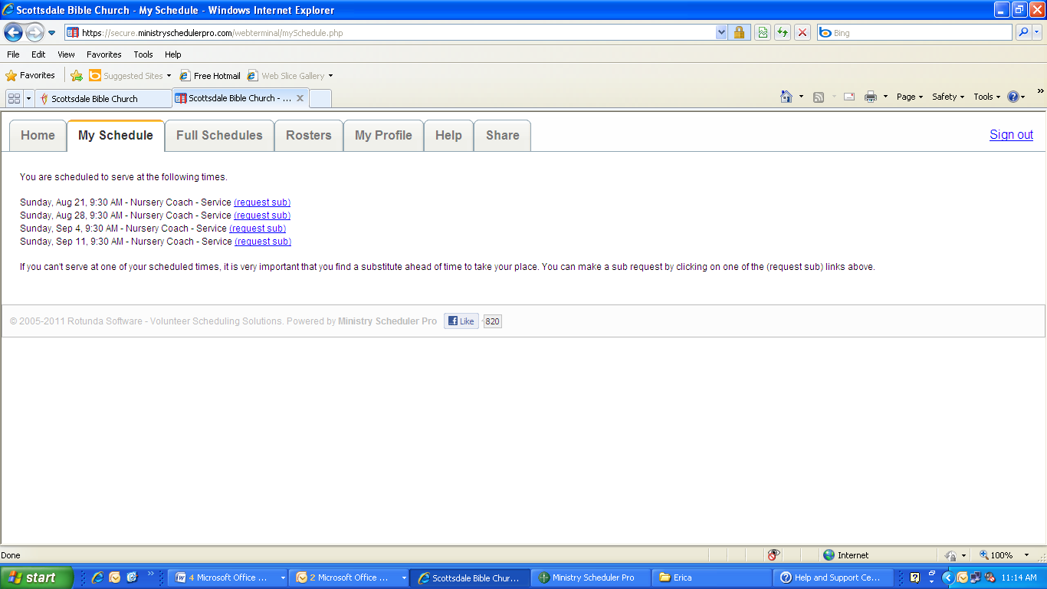

**As stated here is the list of your scheduled dates to serve.**

**To request a sub click on (request sub) this is highlighted in blue.**

**PROCESSING A SUB REQUEST FORM:**

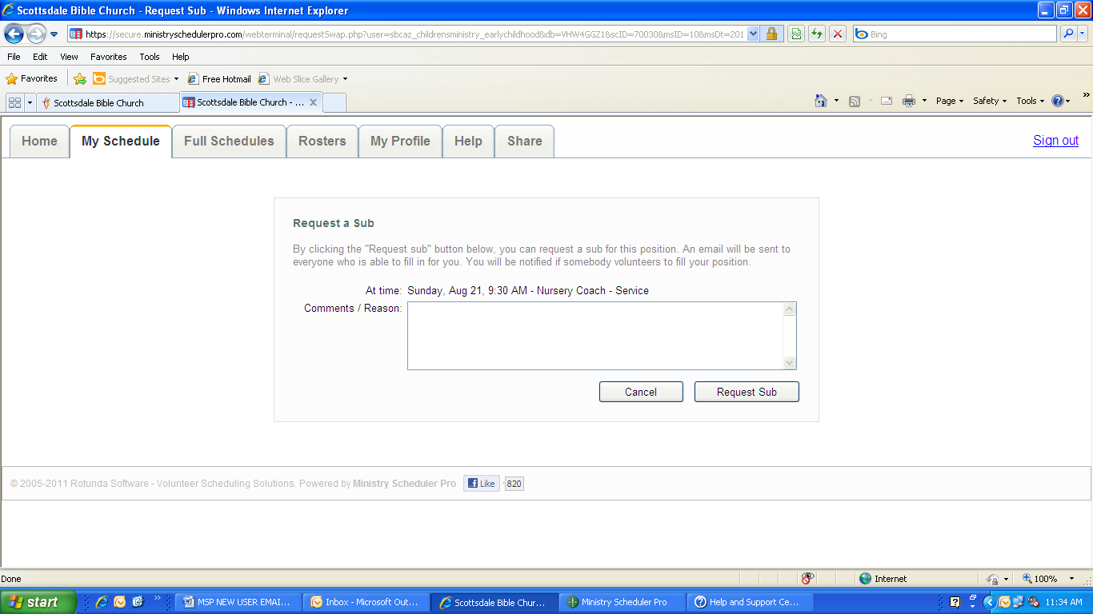

**After entering your notes you must click on the request sub box to submit your request. Once you have submitted your request the volunteer scheduler will see the request and will work with you to plan accordingly.**

**You may enter notes here such as: going out of town, willing to exchange with someone, etc.**

**ASSIGN YOURSELF TO A SHIFT:**

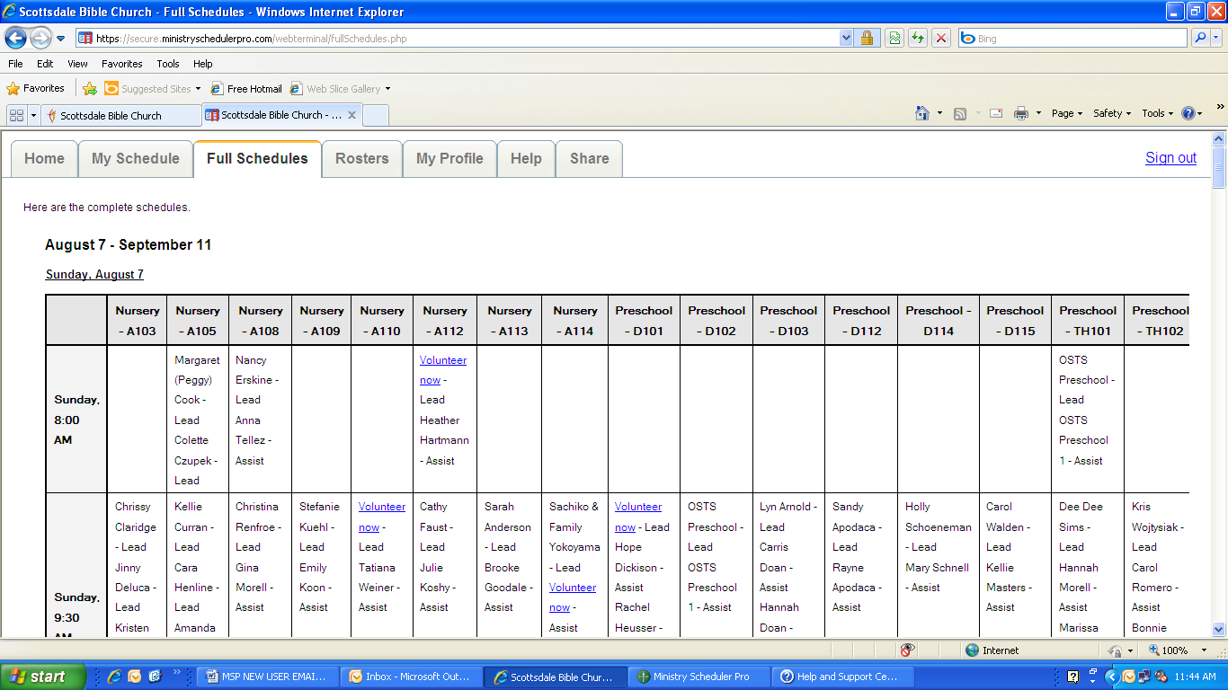

**Below Aug. 7-Sept.11 , the date Sunday, Aug. 7 appears. This is the date for the schedule in view. The top rows display the classroom and the far left column displays the service time. You may click on Volunteer Now to volunteer to serve in this open slot.**

**Click on the Full Schedules tab to view all Sundays within the specified dates. In this example the dates are Aug. 7 – Sept. 11**

**REQUEST A FUTURE DATE a.k.a “Can’t Serve Dates” OFF:**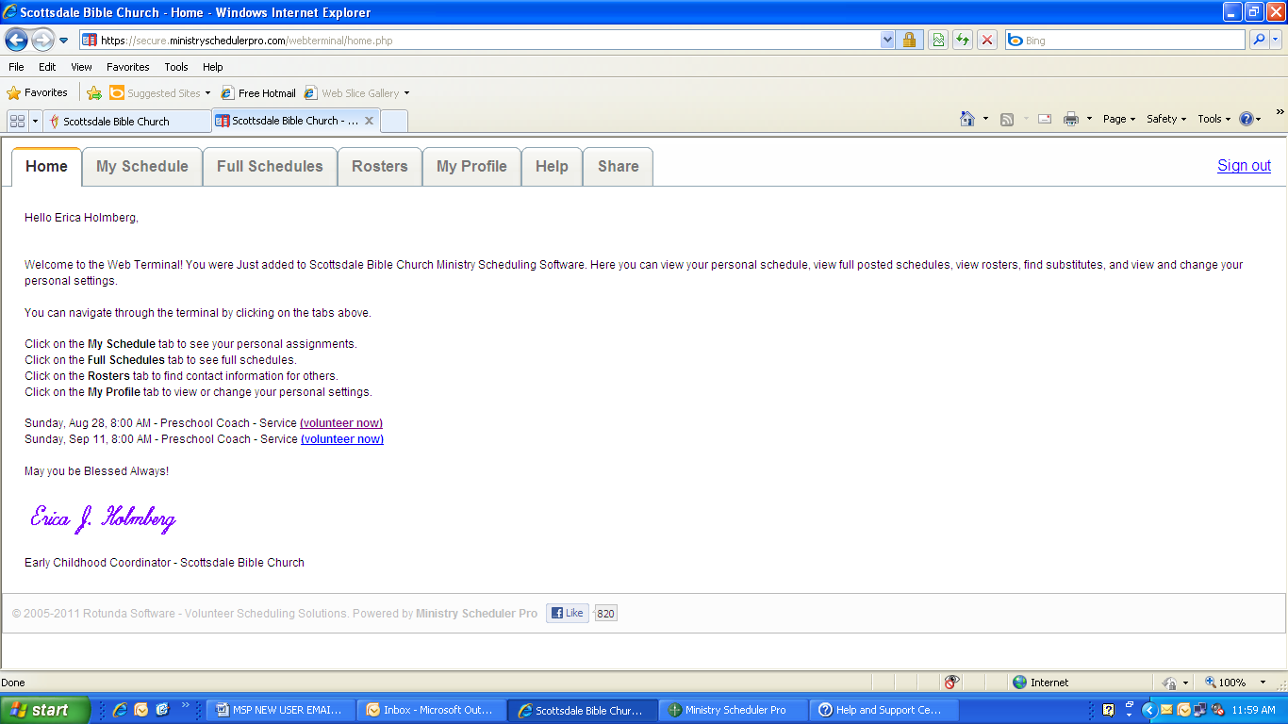

**To request future dates off, first you must click on the My Profile tab.**

**NOTE: After you click on My Profile, use the scroll bar on the right side of the screen until you see : Can’t Serve Dates/Time as seen below.**

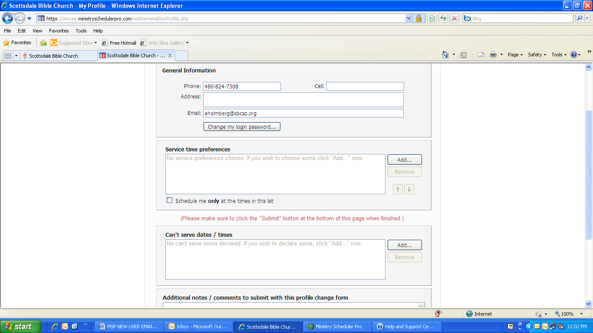

**Click on Add…**

**To submit your future request off dates.**

**REQUEST A FUTURE DATE a.k.a “Can’t Serve Dates” OFF (continued):**

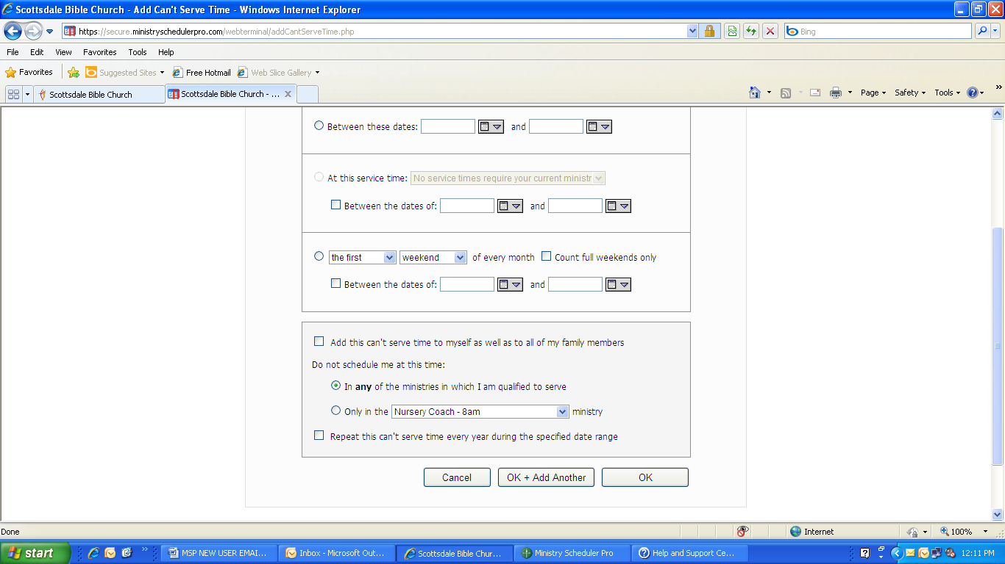

**Click on OK to submit your dates.**

**Click on the Calendar drop down and select the date you are requesting off. Then in the second Calendar drop down select the** **same date if you are requesting just one Sunday, or enter the final Sunday you are requesting off for more than one consecutive Sundays. If the Sundays are not consecutive, you must submit the dates separately.**

**Safety & Security in the Classroom**

**Lockdown & Evacuation**

**Please refer to the next page for the Lockdown & Evacuation insert.**

**Reducing the Risk**

The first and foremost obligation we have to our children is safety. As a ministry and church staff, we have established policies and procedures to be followed along with those set for us by law. Below are the measures we take to reduce the risk of safety and security violations:

* **We require that all Volunteers complete the Volunteer On Boarding process.**

(Please refer to page 7 for full process details)

* **Children’s Ministry volunteers must wear a name tag at all times while serving.**

Your identification confirms you have completed our Volunteer On Boarding process and authorized to care for children.

* **Leave the door open at all times while you help a child in the bathroom.**

Remember, do not enter a bathroom with a child/children unless absolutely necessary.

A volunteer is never to be alone one-on-one with a child. If a child must stay in for asthma or allergies, always ask a ‘buddy’ to stay in too. In cases such as these, you may be with two children.

* **Do not walk around the campus with a child.**

If you need to take a child outside in a stroller, please keep them within the gated Nursery area.

* **Report any inappropriate behavior immediately to your Coordinator or Ministry Pastor.**

**Sick Policy**

In order to keep everyone healthy and control the spread of viruses, it is important to recognize if a child exhibits one or more of the following symptoms:

* Diarrhea or vomiting
* Fever of over 100 degrees
* Colored mucus coming from the nose or eyes
* Unexplainable skin rash
* Persistent cough

If a child has one or more of these symptoms please redirect the parent and child to Kidz Check to obtain approval from a ministry coordinator. If the systems appear after check in, please contact Kidz Check immediately. Kidz Check will contact a coach or ministry coordinator and contact the parents if necessary.

**Responding to an Allergic Reaction**

In the event of an allergic reaction, please see EpiPen instructions below and administer the EpiPen immediately. Once the EpiPen is administered please proceed as follows:

* Contact Kidz Check and advise them you have just administered an EpiPen.
* Kidz Check will contact our First Responders Team. We have a nurse and police officers on campus during Sunday programming.
* Be prepared to provide your location and child information.

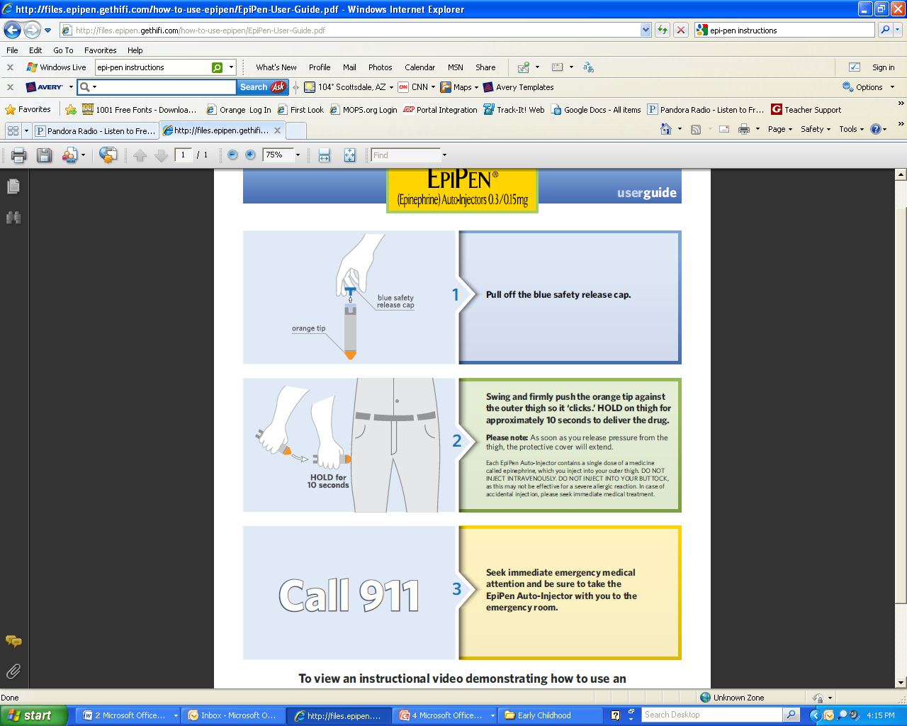

**Restroom Policy**

The following guidelines should be followed when assisting children to the restroom.

Only adults should escort/assist children to the restrooms. Classrooms with children under the age of 4 years old have dutch doors which allows to keep the top door open upon the request of the child. If you must assist a child with their clothing bring the child to the frame of the door and explain how you are assisting them with their clothing to allow them to use the restroom.

Children ages 4 and up may use restrooms with individual stalls. Upon escorting the child to the restroom knock on the door and verify that the entire area is vacant. Prop the door open or stand outside the door close enough to hear the child. Remain outside the door until the child has completed their visit and escort the child back to the classroom safely. If bringing one or more children, remain outside by the restroom door. If you must enter, never remain alone in the restroom with a child.

**Physical Contact Guidelines**

**As we build relationships with our children it very easy to get comfortable in how we display care and affection. For your safety and our children’s here are some fun & appropriate ways to connect**:

* Short congratulatory or greeting hugs
* High-fives
* Handshakes
* Walking hand in hand
* An arm around the shoulder
* Brief pat on the back or shoulder
* Use good judgment at all times

**Never do the following:**

* Never touch a child in anger.
* Never let a child sit on your lap. Exceptions are allowed when caring for young children needing to be fed or comforted.
* Never touch a child in any inappropriate or questionable manner.

**Accident/Incident Process**

In the event a child is injured, causes injury, or is presenting disciplinary challenges please follow these steps:

* **Remain calm.**
* **Contact Kidz Check.** Kidz Check will contact the coach/coordinator.
* **Complete an incident report.** The coordinator will complete an incident report. The report has two parts: part one is the original and kept for our ministry records part two is the copy which is to be given to the parent upon pick up. It is imperative the form is completed in its entirety.
* **Contact the child’s parent.** The coach/coordinator will determine whether it is necessary to remove the child from the classroom and contact the child’s parent accordingly.
* **Discuss the incident with the parent.** When the child is picked up, the classroom leader, coach/coordinator should discuss the incident with the parent and have the parent sign the form as designated.
* **File the report.** If a coach completed the form, the coach must advise the coordinator and turn in the report for proper filing.
* **Notify security.** If the accident/incident is an emergency Kidz Check must notify security immediately and immediately follow our emergency procedures. (please refer to page ??)

Please be advised, during Sunday programming, our team of First Responders, Security, and On-Call Nurse are readily available for immediate response.

**Discipline Policy**

If a child is exhibiting challenging behavior (i.e. disruptive to class, disrespectful to volunteers or other children, physical aggressions, tantrums, etc.), please follow these steps:

* **Remain calm**. Your tone and words may aggravate the child’s behavior.
* **Give the child a firm verbal warning**. Pull the child aside and calmly issue the verbal warning.
* **Issue a time out.** If the child’s behavior does not change pull the child aside and advise them since they were given a previous warning they will be given a time out break. You may have the child sit in a chair on a chair or stand in an area away from the rest of the class. Time out break should not exceed the standard time of 1 minute per the number age of child, for example a

3 yr. old child time out break should not exceed 3 minutes.

* **Contact Kidz Check**. If the child’s behavior continues be a challenge after the above steps have been implemented please contact a Kids Check immediately and a coach or coordinator will be dispatched to your area. Once the coach or coordinator arrives, the child will be removed from the classroom and brought to Kidz Check. The coach will determine if it is necessary to follow the incident process and contact the child’s parent/guardian.

**Safety & Security Review**

**Q: Where are First Aid Kits located?**

*A:*

**Q: What are the steps of a Fire Evacuation?**

*A:* ***Fire Evacuation steps***

1. *Listen*

*_____________________________________________________________________*

1. *Grab*

*_____________________________________________________________________*

1. *Place proper*

*____________________________________________________________________*

1. *Check*

*____________________________________________________________________*

1. *Place “Fire Evacuation Magnet”*

*____________________________________________________________________*

1. *Communicate _____________________________________________________________________*
2. *Lead*

*____________________________________________________________________*

1. *Sit children*

*_____________________________________________________________________*

1. *Parents will*

*_____________________________________________________________________*

**Q: What is the one key thing to bring with you in the event of an evacuation?**

*A:*

**Q: When will your background check expire?**

*A:*

**Safety & Security Review (cont.)**

**Q: What is the procedure when assisting/escorting a child to the restroom?**

*A:*

**Q: Where do you go to see my schedule?**

*A:*

**Q: What time should you arrive to serve?**

*A :*

**Q: When a parent is checking in, what do you check on the child label?**

*A:*

**Q: Aside from maintaining the safety of our children, what is most important thing we do for our children?**

**Children’s Welcome Center**

Kidz Check page 22

New Family Orientation page 22

**Kidz Check**

Our Kidz Check Ambassadors are anxiously awaiting the opportunity to welcome new families to Scottsdale Bible Church. Whether through our Family Welcome Center or at one of our check-in kiosks, our Kidz Check Ambassadors serve as a point of contact to our visiting guests.

Here are the ways they serve our families:

* **Welcome and Register New Guests**

When a new guest arrives, our team in Kidz Check will check the data base to ensure they haven’t visited with us in the past. If after searching we find they have not previously visited us, they will be asked to complete the guest registration form which will capture all necessary information to begin a lifelong relationship with our guest family. This sheet will capture all of the important contact information for the parents and children, including medical and allergy information as well as photo and medical releases for the children.

* **Assist Returning Families**

A Kidz Check Ambassador may be found at one of our check-in kiosks. If there are any challenges with finding a family profile or printing the name tags, our Kidz Check Ambassador will be there to resolve the issue.

* **Knowledgeable of our Ministry Resources**

Within Kidz Check there are various resources available for our families. Our Kidz Check Team is available to answer questions or redirect our families, if necessary, to serve their needs.

**New Family Orientation**

As we continue to reach out to our family, friends, and communities our ministry is prepared to make our guests feel comfortable and welcomed!

We have set aside a special time twice a month to offer our guests an orientation which allows them tour our campus and classrooms. This one-on-one opportunity allows our guests to ask questions and learn about the resources our church and ministry has to offer. Orientations are scheduled on the 1st and 3rd Sunday’s of the month; advanced notice is appreciated however we welcome walk ups!

**Classroom Procedures**

Décor & Maintenance page 24

Sanitation page 24

Check-In/Out Procedure pages 25-26

Room Closure Process page 27

**Décor & Maintenance**

We take great pride in the environment we create for the children in our ministry.

We encourage our volunteers to take ownership of their classrooms and service areas, whether its through decorating or just maintaining your area, please keep the following standards in mind:

* Please feel free to utilize our Media Resource Center (MRC) for supplies when decorating your room. Access to the MRC is available on Sundays during normal service times however you may also visit on weekdays with advance notice.
* Please refrain from using packing tape or masking tape on any area in our ministry. These types of tape damage our property. Blue painter’s tape is available in the MRC and is the only approved tape. We prefer that you staple items to walls and doors.
* When serving in a classroom please be sure to sanitize all toys, counter tops and furniture prior to your departure. Each room has a bottle of disinfectant (water and vinegar mixture), this is the only approved mixture as it is natural and free of allergens and potentially harmful chemicals.
* Please replace all furniture to its original set up. This is extremely helpful for our facilities team and ensures the necessary furniture remains in your classroom.
* Report all maintenance issues (i.e. loose cabinet doors, broken furniture, leaking faucets, etc.)
* All posters and signs must be approved by your area coordinator prior to posting.

**Sanitation**

Maintaining a clean and sanitized area is imperative to restraining the spread of viruses and illness. Please adhere to the following standards:

* Be sure to sanitize the hands of each child prior to allowing them entrance into class.
* Please refrain from bringing personal food and open beverages to your classroom. This helps us eliminate bug infestation.
* Discard all trash and liquids (from bottles/cups left behind) in the proper receptacle and spray the area with disinfectant provided in the classroom.
* Prior to serving snacks/beverages and changing diapers please sanitize your hands and use the plastic gloves provided.
* Disinfect all toys, counter tops, and furniture prior to your departure.
* Report any appearance of bugs or unusual odors.
* If a child becomes sick in a classroom (i.e. vomits) please refer to the Incident Reporting Process (page 18) and be prepared to move your entire class to an alternate location.

**Check-In/Out Procedure**

**Check-In for Regular Attendees**

Parents will use the check-in kiosks to register their children for on campus programming.

Once a child has been checked in, 3 labels per child will print. Parents will place the labels as instructed in the picture below:

**Child Label:**

**This label is to be placed on the child prior to entering the class.**

**Teacher Label:**

**This label is to be placed in the classroom attendance binder.**

**Child Receipt:**

**Must be kept by the parent for pick up.**

See Check-Out process.



**Check-In for New Guest Families**

Each family will receive a multiple part form. This form must be completed in its entirety at registration in Kidz Check. Please see the picture below for further instructions:

**Child 1 Teacher Copy:**

**This copy is to be given to the teacher upon drop off of child.**

**Parent Copy:**

**Parent must keep this as their pick up slip for child.** .check out.

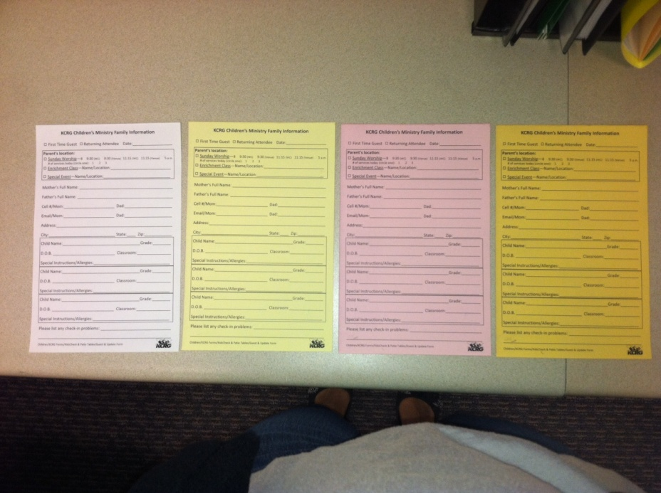

**Child 2 Teacher Copy:**

**If there is a second child this slip will be given to the second** **teacher.**

**Original Copy:**

**Remains in Kidz Check for further entry.**

**Check-In/Out Procedure (cont.)**

**Check-Out for Attendees**

Upon pick up parents must present their child receipt or new family registration slip prior to releasing the child from your classroom. Please follow the steps below upon child check-out:

* Parent will provide the teacher with the check-out label or slip.
* Teacher will verify the security number at the top left corner of the label.
* Important note: this number changes each time a child is checked into a class, if the number is different do **not** release the child. When checking out a new family child, please verify that the information matches the teacher slip copy provided at check-in.
* Once you have received the matching child receipt label or slip, please remove the label which was placed on the child and place both in the binder as instructed in the picture below:



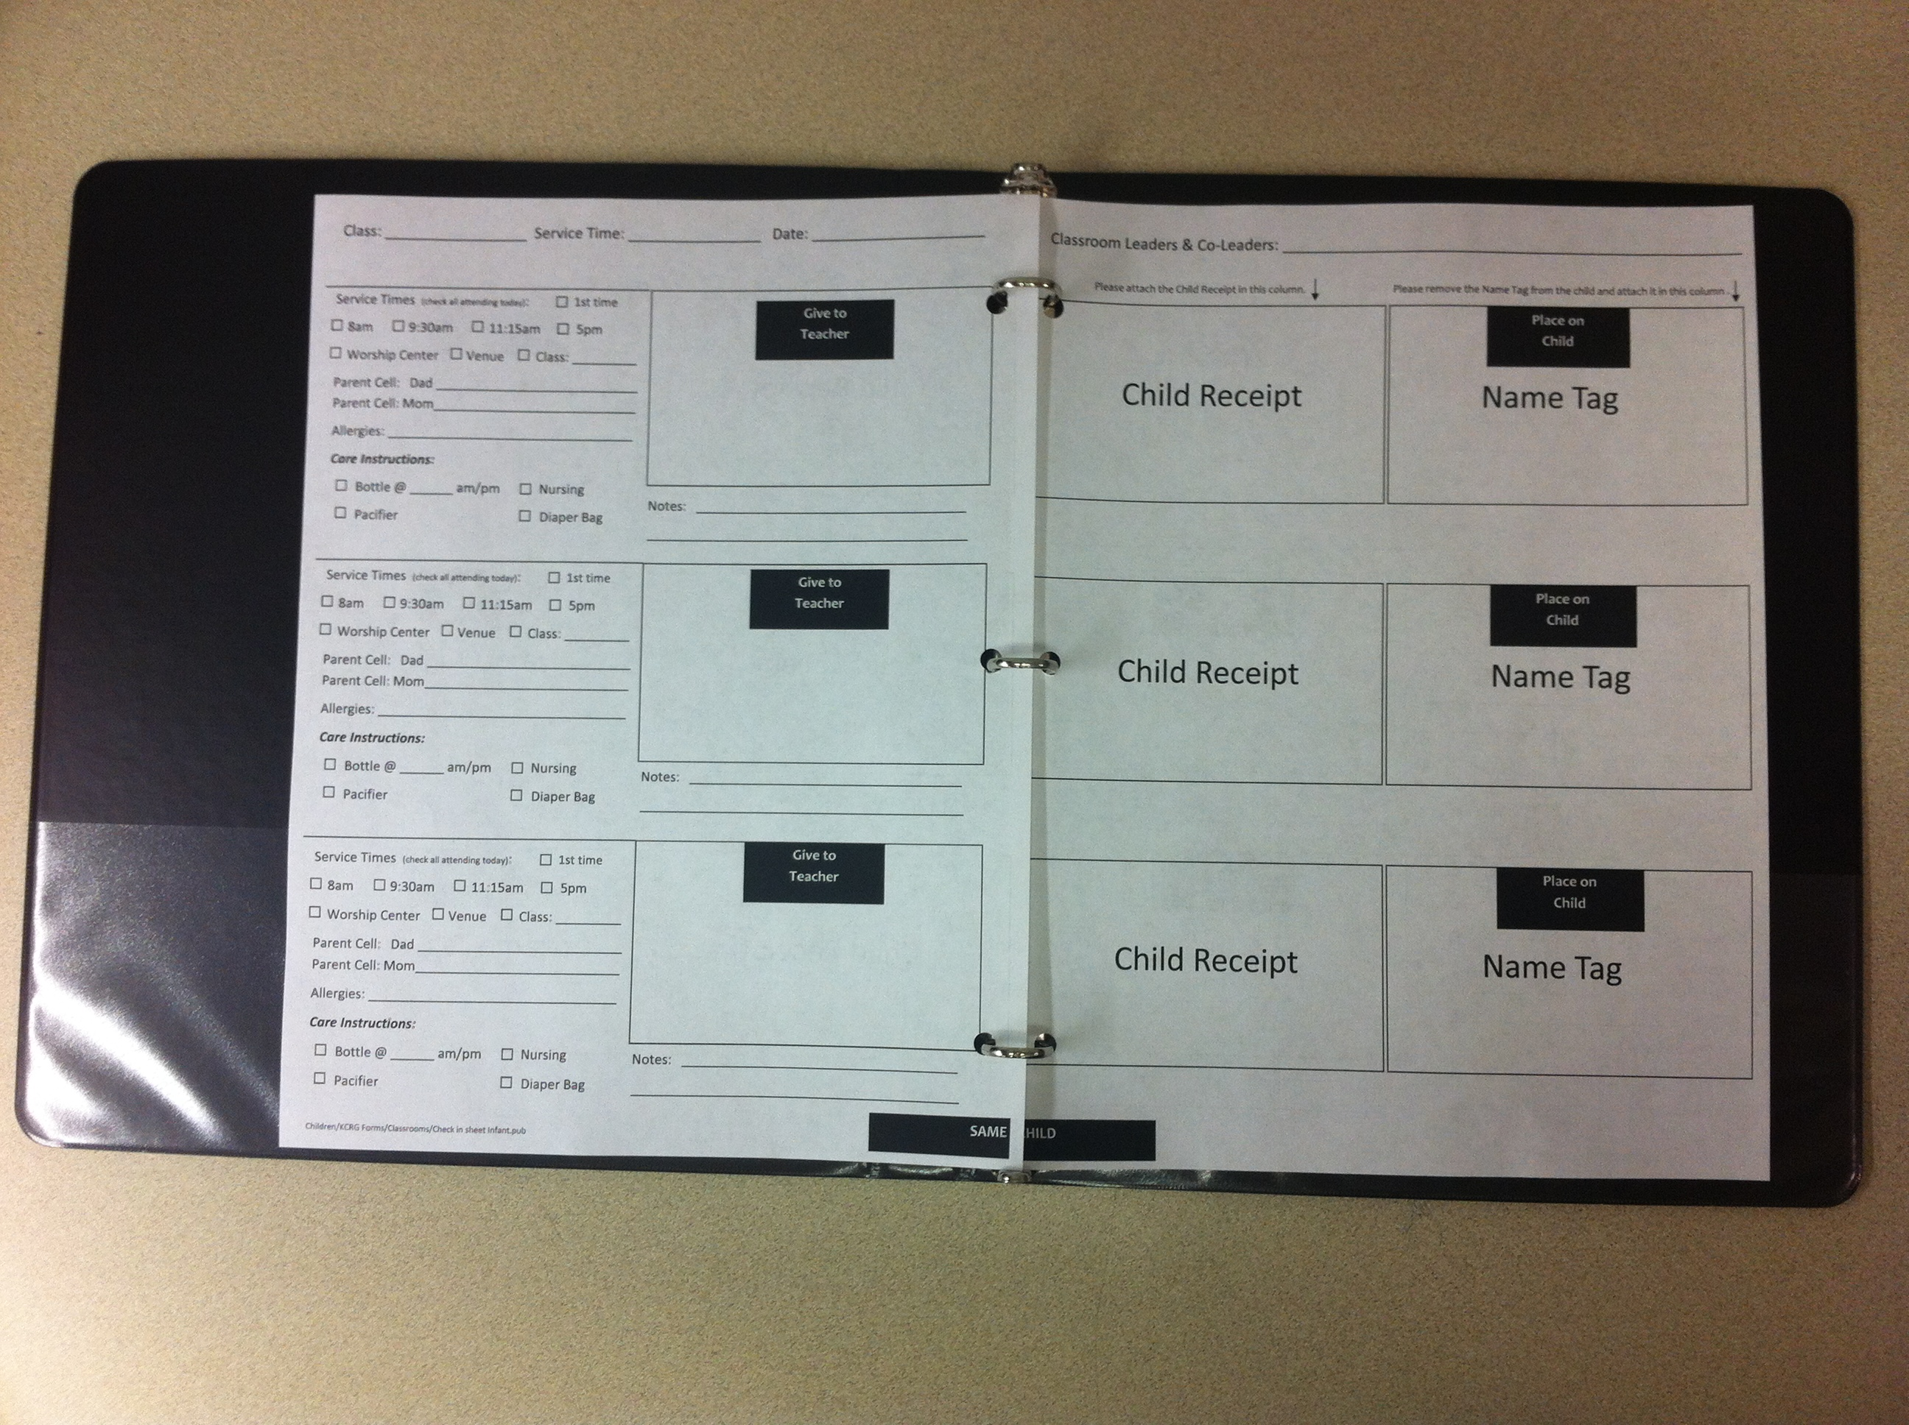

**Child Information:**

**This part of the classroom check- in sheet must be filled out if the child’s teacher label has incomplete information or needs updated information. Nursery sheets must be completed at each check- in.**

**Room Closing Process**

Once all children have left your room please complete the following tasks:

* Put away all art supplies and table activities in their designated containers on the labeled shelves.
* Close snack containers tightly and return it to its storage area.
* Throw away all trash including, children’s papers, crafts, etc.
* Straighten the reception desk.
* Collect all New Family Registration Forms and place in the front pocket of the attendance binder.
* Empty and rinse forgotten cups and bottles.
* Use carpet sweeper to clean crumbs and debris from floor.
* Wash any toys that were played with or that appear to be dirty.

Spray with vinegar solution, rinse, dry and put away.

* Make sure all toilets are flushed and dirty diapers are placed in

Diaper Genie, **not trash can**.

* Turn off lights in bathroom & classroom.
* Collect Lost & Found items and unused craft materials and return to your Volunteer Studios (Nursery & Preschool is D105, Elementary is D205)
* Close classroom door behind you when leaving.

**Weekend Programming & Curriculum**

Children’s Weekend

Large Group Worship page 29

Classroom Schedule page 30-33

1. Elementary
2. Preschool – 3 & 4 Year Olds
3. Preschool – 5 Year Olds
4. Nursery

Weekend Curriculum Overview page 34

The Gospel Project

Scope & Sequence page 35-38

**Children’s Weekend Large Group Worship**

We have designed a time when all kids come together to worship and learn according to their age group.

**The Broadcast Room**: First- through fourth-grade students will experience live bands and dynamic worship leaders as we pursue cultivating a heart of worship. In addition, large group teachers will use the Bible to teach God’s truth and make the lessons come alive. Each week kids will learn that everything in the Bible is true, timeless and relevant to today’s world. Each month our radio and TV station personalities (the Broadcast drama team) will instruct the students in life lessons and biblical truths through drama and other media avenues that tie in directly with our curriculum.

**Tree House:** Tree House is the most exciting place on campus for kids ages three to five! Each week the Tree House gang will share creative Bible teaching through puppetry, worship, video, storytelling and more.

**Noah’s Adventure:** At Noah’s Adventure, our almost 2s up to preschool-age children get to experience a short Bible lesson with Squeaks (our favorite puppet in Noah’s Adventure) along with our gifted Bible storytellers. In addition to the Bible lesson, kids will work on motions for the week’s Bible verse and pray together.

**Weekend ELEMENTARY Classroom Schedule**

5pm 8:00am 9:30am 11:15am

**Weekend PRESCHOOL Classroom Schedule**

**3 & 4 Year Olds**

5pm 8:00am 9:30am 11:15am

**Weekend PRESCHOOL Classroom Schedule**

**5 Year Olds**

5pm 8:00am 9:30am 11:15am

**Weekend NURSERY Classroom Schedule**

5pm 8:00am 9:30am 11:15am

**Weekend Curriculum Overview**

TOP 10 Things to Know about The Gospel Project

1. Chronological Bible Stories
   * Beginning year 2 of 3
   * 1 Kings – Malachi
2. Every Unit and Every Lesson Points to Jesus – Christ Connection
3. Teacher Bible Study for Each Session – Please read & study for your own personal growth
4. One Key Passage for Each Unit – Use NIV version

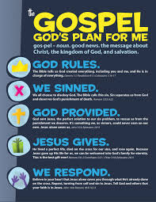

1. One Big Picture Question for Each Session (weekly)
2. Age Differentiation:
   * 2 and 3 year olds
   * 4 and 5 year olds
   * 1st and 2nd grade
   * 3rd and 4th grade
3. Plan of Salvation – presented to Elementary kids (5 Key Ideas: God Rules, We Sinned, God Provided, Jesus Gives, We Respond)
4. Activity Sheets Provided Each Week
5. Take Home Page Provided Each Week
6. Christmas and Easter Units are Inserted at the Appropriate Seasonal Times

Each lesson is available on the Teacher Resource Page

<http://scottsdalebible.com/ministries/children/volunteers/teacher-resource-page>

Questions or comments? Contact Kelli McAnally at 480.824.7212 or [kmcanally@sbcaz.org](mailto:kmcanally@sbcaz.org)

**Children’s Ministry**

**Scope & Sequence 2013-2014**

**Unit Title:** A Kingdom in Trouble

**Dates: Bible Story Titles**:

8/18/13 Solomon Asked for Wisdom (1 Kings 2:1-4, 10-12; 3:1-15)

8/25/13 Solomon Built the Temple (1 Kings 6:1-8:66)

9/1/13 King Solomon’s Sin Divided the Kingdom (1 Kings 11-12)

9/8/13 Poetry and Wisdom (Psalms, Proverbs, Ecclesiastes)

***Unit Christ Connection****: Solomon’s grand earthly reign is a picture of the eternal reign of Christ. Solomon’s sin divided his kingdom, but Christ’s perfect kingdom is forever.*

***Fall 2013***

**Unit Title**: Israel, The Northern Kingdom

**Dates: Bible Story Titles:**

9/15/13 Israel’s History of Evil Kings (1 Kings 16)

9/22/13 Elijah Confronted Evil Ahab (1 Kings 18)

9/29/13 Elijah Ran from Jezebel (1 Kings 19)

10/6/13 Elisha and Naaman (2 Kings 5)

10/13/13 The Northern Kingdom Was Destroyed (2 Kings 17:1-23)

***Unit Christ Connection****: The prophets called God’s people to repentance as Christ calls people to repentance. Sin continued to divide and ultimately destroy the Northern Kingdom but Christ’s perfect kingdom is forever.*

**Unit Title**: Great Prophets

**Dates: Bible Story Titles:**

10/20/13 Amos, Prophet to Israel (Amos 1-9)

10/27/13 Hosea, Prophet to Israel (Hosea 1-14)

11/3/13 Jonah, Prophet to Ninevah (Jonah 1-4)

11/10/13 Joel, Prophet to Judah (Joel 1-3)

***Unit Christ Connection****: Through these prophets we see a picture of the salvation provided through Jesus Christ.*



**Unit Title**: Isaiah, Prophet to Judah

**Dates: Bible Story Titles:**

11/17/13 God Called Isaiah (Isaiah 6)

11/24/13 Isaiah Confronted Ahaz (Isaiah 7)

12/1/13 Hezekiah, Judah’s Faithful King (2 Kings 18-20)

12/8/13 Isaiah Preached About the Messiah (Isaiah 53)

***Unit Christ Connection****: God’s promised Messiah comes out of David’s family, and is described in Isaiah’s prophecy.*

***Winter 2013-2014***

**Unit Title**: Christmas

**Dates: Bible Story Titles:**

12/15/13 Angels Spoke to Mary and Joseph (Luke 1:26-56, Matthew 1:18-24)

12/22/13 Jesus Was Born (Luke 2:1-20)

12/29/13 Simeon and Anna Recognized the Savior (Luke 2:21-40)

***Unit Christ Connection****: The Savior God had promised was born!*

**Unit Title**: Judah, The Southern Kingdom

**Dates: Bible Story Titles:**

1/5/14 Micah, Prophet to Judah (Micah 1-7)

1/12/14 Josiah’s Reforms (2 Chronicles 34-35)

1/19/14 Zephaniah, Prophet to Judah (Zephaniah 1-3)

1/26/14 Habakkuk, Prophet to Judah (Habakkuk 1-3)

2/2/14 Nahum, Prophet to Nineveh (Nahum 1-3)

***Unit Christ Connection****: God judges sin but redeems those who faithfully follow His commands. Redemption for all comes through faith in Jesus Christ.*



**Unit Title**: The Exile Began

**Dates: Bible Story Titles:**

2/9/14 God Called Jeremiah (Jeremiah 1)

2/16/14 Jeremiah Warned of God’s Judgment (Jeremiah 36)

2/23/14 Judah Was Taken into Captivity (2 Chronicles 36:1-21)

3/2/14 Ezekiel Prophesied to the Exiles (Ezekiel 10)

3/9/14 Ezekiel Told About a Future Hope (Ezekiel 37)

***Unit Christ Connection****: Though it appeared that sin prevailed, the covenant God promised would be fulfilled in Jesus Christ.*

***Spring 2014***

**Unit Title**: Daniel

**Dates: Bible Story Titles:**

3/16/14 Daniel and His Friends Obeyed God (Daniel 1)

3/23/14 Shadrach, Meshach, and Abednego (Daniel 3)

3/30/14 God Gave Daniel Wisdom (Daniel 5)

4/6/14 Daniel Was Rescued from the Lions (Daniel 6)

***Unit Christ Connection****: Despite captivity, God used faithful people to continue His plan to provide salvation through Jesus Christ.*

**Unit Title**: Easter

**Dates: Bible Story Titles:**

4/13/14 The Triumphal Entry

(Matthew 21:1-17; Mark 11:1-11; Luke 19:28-44; John 12:12-19)

4/20/14 Jesus’ Crucifixion and Resurrection (John 18:1-20:18)

4/27/14 Jesus Appeared to the Disciples (John 20:24-29; Mark 16:14)

***Unit Christ Connection****: God’s plan for redemption is fulfilled through the death and resurrection of Jesus Christ.*



**Unit Title**: The Exiles Returned

**Dates: Bible Story Titles:**

5/4/14 Obadiah the Prophet (Obadiah 1-9)

5/11/14 Zerubbabel Led the Captives Home (Ezra 1:1-2:22; 2:64-3:13)

5/18/14 Haggai, Prophet to Judah (Haggai 1-2)

5/25/14 Zechariah, Prophet to Judah (Zechariah 1-14)

6/1/14 The Temple Was Completed (Ezra 4:24-6:22)

6/8/14 Esther Saved Her People (Esther 4:1-5:14; 7:1-10)

***Unit Christ Connection****: God saved His people who are in physical captivity as He would one day send Jesus to save and restore His people who are in spiritual captivity.*

***Summer 2014***

**Unit Title**: Jerusalem Was Rebuilt

**Dates: Bible Story Titles:**

6/15/14 Nehemiah Heard News of Jerusalem (Nehemiah 1-2)

6/22/14 Jerusalem’s Walls Rebuilt (Nehemiah 3:1-6:16)

6/29/14 Ezra Read the Law (Nehemiah 8:1-12)

7/6/14 Malachi the Prophet (Malachi 1-4)

***Unit Christ Connection****: God restored a faithful remnant and reminded them of His promise of a new covenant through Jesus Christ.*

**Unit Title**: The Forerunner of the Savior

**Dates: Bible Story Titles**:

7/13/14 Genealogy of Christ (Matthew 1:1-17; Luke 3:23-38)

7/20/14 John’s Birth Was Predicted (Luke 1:5-25)

7/27/14 Mary Visited Elizabeth (Luke 1:39-56)

8/3/14 John Was Born (Luke 1:57-80)

***Unit Christ Connection****: As prophesied in Isaiah 43 and Malachi 3, John the Baptist prepared the people for the coming Messiah.*

**AWANA**

Important Dates & Key Contacts page 40

Keys to a Successful AWANA Year page 41



**Welcome Leaders!**

**Important Dates**

August 29, 2012 Training

September 5, 2012 Open House

September 12, 2012 Club Begins

November 21, 2012 No Club/Thanksgiving

December 5, 2012 Sparks Store

December 12, 2012 T&T Store

December 26, 2012 No Club/Winter Break

January 2, 2013 No Club/Winter Break

March 27, 2013 No Club/Spring Break

April 13, 2013 Grand Prix

April 24, 2013 T&T Store

May 1, 2013 Sparks Store

May 8, 2013 AWANA Awards Night

**Key Contacts**

Commander Sue Krauser

480.824.7279 (office)

847.417.0220 (cell)

[skrauser@sbcaz.org](mailto:skrauser@sbcaz.org)

Coordinator Renee Bickers

480.824.7220 (office)

[rbickers@sbcaz.org](mailto:rbickers@sbcaz.org)

T&T Director Rick Krauser

847.494.5004 (cell)

[rkrauser@aol.com](mailto:rkrauser@aol.com)

Sparks Director Candace Schmall

559.304.6952 (cell)

[awanasparksdirector@yahoo.com](mailto:awanasparksdirector@yahoo.com)

Cubbies Director Erika Lopez

480.319.5053

[lopez_erika@ymail.com](mailto:lopez_erika@ymail.com)

**Keys to a Successful AWANA Year**

***Arrive on Time***

It’s important to have a calm and prepared room ready to receive children. Please arrive to your classroom no later than 6:15 p.m. For check-in and room closing procedures, please see pages 25-27 of this manual.

***Wear Uniform and Nametag Every Week***

For safety and security it is important to come dressed in your uniform shirt and wear your picture ID while serving. If you have not yet had your ID made, we will be ready in Kidz Check to accommodate you.

***Large Group Assistance***

Please stay with your children during large group programming and ensure that they are participating according to the leader’s instructions (which may include sitting quietly).

***Game Time***

Leaders are needed to assist the game team by helping organize and instruct the children according to the directions given by the game leader. It is also important to help the children line up properly and to encourage participation of all clubbers during game time. Proper shoes are required for some games. Sandals and open-toed shoes are not permitted for game time. Please encourage your clubber to wear athletic shoes each week to AWANA.

***Pray for Your Children and Their Families***

Over the course of the year, you will get to know the children in your group as well as their family situations. Prayer support for them and their family members, both for growth in Christ and peace in their home, is a special gift you can give in addition to your weekly service. Please spend a few minutes prior to each club night praying for your classroom children as well as their families.

**AWANA BUCKS GUIDELINES**

Award AWANA Bucks to your classroom children using the following criteria:

* Award 1 Buck for attendance
* Award 1 Buck if they wear their uniform
* Award 1 Buck for bringing their handbook
* Award 2 Bucks for each section they complete

AWANA Bucks cannot be given out for any other reason unless authorized by the Director of your area.

**Volunteer Resources & Calendar of Events**

Helpful Tips page 43-48

Media Resource Center (MRC) page 49-51

Key Dates for 2012 - 2013 page 52

**Helpful Tips**

How to Prepare for your Lesson page 44

How to be an Awesome Sunday School Teacher page 45

Classroom Co-Lead Overview page 46

Meeting the Needs of a Young Child page 47

Diapering Procedure page 48

**How to Prepare for your Lesson**

Here are a few quick tips on how to use this curriculum to lead your class:

1. Be aware of what Sunday services you are scheduled to serve. Please look over the schedule at the beginning of each month and mark these dates on your personal calendar.
2. Familiarize yourself at the beginning of the week with the week’s story by reading the scriptures that coincide with it (located on the Scope and Sequence).
3. Your story and craft are emailed to you by Wednesday. Please open the email and read through the important communication.
4. Read through all of the lesson ideas **before** Sunday morning. Gather the supplies you need from home and let your Coach or Director know if you need any other unique supplies. Feel free to adjust any activities to make them more specific to your group’s personality and/or needs.
5. Pray for your time with the children in your room. This is such a vital part of the presentation to ensure God is working through you for His purpose and plan.
6. Attend our pre-service briefing and report to class on time. By showing up late, you are disrupting the team. If you don’t show up, your class will be left without a teacher and possibly combined with another class. Large classes are subject to injury, safety issues, and produce a disruptive environment for learning. This adds stress to the team and lessens the effect of our ministry.
7. When serving with the children, repeat, repeat, repeat and repeat some more. Use the main point of the lesson throughout your entire time in class.

**How to be an AWESOME Sunday School Teacher**

**1. Make a Commitment**

Becoming a Sunday School teacher is an important decision. To be an awesome teacher, not just a good filler for a leader-less class, you’ll have to be committed. The stellar teacher must be willing to be consistent in attendance.

**2. Build Relationships**

You’ll need to build strong relationships with students, parents and other family members. Get to know family groups by their first names, remember birthdays and important dates and send cards to their home, when possible. Show you care for kids by “being there” regularly. Awesome teachers are involved in their student’s lives.

**3. Come Prepared**

The best teachers are prepared and excited about what they are about to teach. There’s no fumbling for papers, looking for lost items or poor attitudes in “best-teacher universe.” Sure we all have off-days but these shouldn’t be the norm. You can follow the Lord’s leading and deliver timely and meaningful messages that kids can understand and apply. This should be exciting! An awesome Sunday School teacher spends time each week praying for direction, locating the message and gathering everything he or she needs before coming to class.

**4. Be Flexible**

Being flexible is kind of part two for “come prepared.” When the Lord is involved, the best laid plans can get tossed out the window. Sometimes an exceptional opportunity arises that allows us to plant a different spiritual seed than the one we intended. For example, a child with a tender heart comes to class in tears because a loved one passed away. Another had a wonderful dream about heaven. These are all opportunities to give comfort and give guidance, but aren’t necessarily in your lesson plan. Be willing to bend with the wind and walk through the open doors.

**How to Assist in the Classroom**

Classroom Co-Leads are a valuable resource to a teacher.

Please note the tips below to create a great classroom experience.

**Children’s care**

Please help children transition from check-in. If you have a crying child please do the following:

* + Invite to play with others
  + Try to distract with a toy/game or craft
  + Get down on their level and talk with them

Keep the children calm and orderly while doing the following:

* + In line to the playground or big group
  + In Noah’s Adventure/TreeHouse

And remember to always:

* + Count the children to ensure all children are accounted for at all times.
  + Be careful what you say around the children – they will repeat it.
  + Please do not use your cell phones while in the classroom.
* Look for ways to help or children that need extra assistance
* Think about the next step and offer to prepare

(snacks, crafts, clean up)

* Keep children calm and focused on the task
* Do not leave classroom until the teacher dismisses you
* Do not go into bathrooms with the children
* Avoid prolonged tickling, placing children on your lap, and roughhousing.

**Meeting the Needs of a Young Child**

Young children have a very small understanding of how the world works. They have no idea of the consequences of their actions or how another child will respond to them. Part of the process of discipline is to help a child make sense of things as you help the child understand appropriate ways to act. To meet the needs of very young children:

* **Prevent Problems.** Be sure the environment is set up to be a safe and “trouble-free.” Young children need to be able to explore with as little restraint as possible; this helps a child develop his or her own internal controls and reduces stress on babies and adults alike. Also, having several identical toys can help when toddlers both want the same toy. Toddlers are still too young to understand sharing, offering an identical toy can often avoid conflict.
* **Set Clear Limits.** Save the use of the word “no” for dangerous situations in which the child must be immediately restrained. Use the word “no” as little as possible because it does not teach the child an appropriate way to act. Instead, give clear information about the situation.
  + **For example:** “The truck is for rolling. We don’t hit Joey with it. It will hurt him. The truck rolls on the floor. See?”
* **Redirect Behavior**. “Let’s roll the truck. Look! I roll the truck to you. Can you roll it back to me?” Or offer another activity. “Here is a ball. We can roll the ball. Or you may roll the car. Joey will roll the truck.” Do not force a toddler to share or apologize. This only results in adult frustration and toddler confusion! While you model sharing and apologizing, this shows the child how to interact.
* **Offer a Choice**. When you offer, “You may play with the bear or the doll. Which one do you want?” you are giving the child a choice between two acceptable alternatives. You will often find that even the most resistant child is easily redirected!
* **Acknowledge Feelings**. Use the words, “I see…” often. “Sarah, I see you fell down. You hurt your knee. You feel sad.” Acknowledging what you see shows the child you understand and helps the child begin to make sense of his/her emotions.
* **Talk Through Problems**. If you are “talking through’ as you watch children (describing what you see and how children are reacting) you are already in the perfect position to help solve any problem situation going on. “Ryan wants the car. Janna wants the car. What can we do? Here is another car. Here is a truck. Which one would you like, Ryan?”

Of course, the most important part of the opportunity to teach is found in the way you behave! As you model caring and respectful behavior and follow the above guidelines to meet children’s needs in appropriate ways, you will find not only the nursery is more peaceful, but also that you are naturally helping children make sense of their world and solve their own problems. This also shows children that their caregivers are loving and considerate people who want to help them. And that is the essence of showing God’s love to little ones! *Nursery Smart Pages, pg. 111, Gospel Light, 1997*

**Diapering Procedures**

* Spray off the changing pad with disinfectant and wipe off
* Wash hands and put on gloves
* Talk with the child about what you are doing. Some children experience a great deal of anxiety when someone other than mom/dad changes them.
* After changing the diaper, throw the dirty diaper in the Diaper Genie.
* Spray the area with the disinfectant and wipe off.
* Discard gloves and wash hands in between each child.
* Mark down the last time that you changed each child on the parent sign-in form.

**Media Resource Center – Supply List**

Please utilize our phenomenal craft supply center and many reference books, located behind Kidz Check.

Periodically, décor and craft ideas are posted on the board or placed on the counter at the MRC. We encourage you to check out the latest additions for inspiration!

Supply list is below. If there is something you need that you don’t see, ask and we will try to accommodate you.

**ALUMINUM CONTAINERS APRONS & GLOVES-PLASTIC ARMOR SETS**

**BABY FOOD JARS BAKING CUPS, paper BAGS, large, paper**

**BAGS, small, paper BALLOONS BEADS**

**BELLS BIBLES BOWLS, paper**

**BUBBLE SOLUTION BULLETIN BOARD EDGING BUTTONS**

**BUTTON MAKING MACHINE CDs (used) CD cases (empty)**

**CHALK CHENILLE WIRES CLIP BOARDS**

**CLOTHES PINS COFFEE CANS COLOR SHEETS**

**CONTACT PAPER CONSTRUCTION PAPER COOKIE CUTTERS**

**COSTUMES COTTON APPLICATORS COTTON BALLS**

**CRAFT BOOKS CRAFT CUPS CRAFTS-left overs**

**CRAFT STICKS CRAYONS CREPE PAPER**

**EASTER EGGS EASTER GRASS EGG CARTONS**

**ELECTRIC KEYBOARD ELLISON CUTOUTS ELLISON TOOLS**

**EXTENSION CORDS FABRIC FEATHERS**

**FELT FIBERFILL FILM CANISTERS**

**FLANNELGRAPH BOARDS FLANNELGRAPH FOAM**

**Media Resource Center – Supply List Cont.**

**FOIL WRAP GAME BOOKS GAMES**

**GLASS GLITTER GLITTER GLUE**

**GLUE GLUE GUNS GLUE STICKS**

**GREETING CARDS KAREOKE KRAFT PAPER ROLL**

**LACING LEATHER SCRAPS MAGAZINES**

**MAGNETIC TAPE MALLETS MAPS**

**MARKERS MESH**

**MUFFIN PAPERS MUSIC INSTRUMENTS NAPKINS**

**NEEDLES NETTING CRAFT BOOKS**

**OVERHEAD MARKERS PACKING PEANUTS PAINT BRUSHES**

**PAINTS PAINT SHIRTS PAPER**

**PAPER CLIPS PAPER DOILIES PAPER FASTENERS**

**PAPER PUNCHES PARACHUTES PENCILS**

**PENCILS, lead PENS PINE CONES**

**PLASTIC BAGS PLASTIC BASKETS PLASTIC FLATWARE**

**PLASTIC WRAP PLATES, paper PLAY DOUGH**

**POLOROID CAMERA POLYFIL POM POMS**

**POSTER BOARD POSTERS PUZZLE PIECES**

**RAFFIA REFRIGERATOR MAGNETS RIBBON**

**ROPE RUBBER BANDS RULERS**

**SAFETY PINS SAND, ART / PAPER SAND, colored**

**SCISSORS, adult, children SEA SHELLS SEQUINS**

**SHARPIES SHAVING FOAM SHEETS (bed)**

**SPONGES STAMPS STAMP PADS**

**Media Resource Center – Supply List Cont.**

**STAMPERS STAPLERS STAPLES**

**STENCILS STICKERS STRAWBERRY BASKETS**

**STRAW STRAWS, drinking STRING**

**STYROFOAM , plates, trays STYROFOAM SHAPES TABLECLOTHS, plastic**

**TACKS TACKY GLUE TAPE**

**THREAD THUMB TACKS TISSUE PAPER**

**TISSUE PAPER pieces TOOTHPICKS TRACTS**

**TRIM, LACE, ELASTIC TRIPODS VELCRO FOR CARPET**

**VIDEOS WIGGLE EYES WIRE**

**WOODEN PIECES WOODEN PINS YARD STICKS**

**YARN**

**Key Dates for 2012-2013**

**Volunteer Team Rally** Friday, 8/17/12

**Children’s Ministry Fall Kick Off** Sunday, 8/26/12

**AWANA Training** Wednesday, 8/29/12

**AWANA Open House** Wednesday, 9/5/12

**MOPPETS (First & Third Thursdays)** 9/6/12–5/2/13

**God’s Kidz (Tuesdays)** 9/11–11/13 (2012)

2/5–4/23 (2013)

**AWANA (Wednesdays)** 9/12/12–5/8/13

*No Club 11/21 & 12/26 (2012)*

*1/2 & 3/27 (2013); Closing Ceremony 5/8/13*

**Legacy Classes (Sundays)** 8/26, 11/18 (2012)

2/17, 6/30, 8/25, 11/24 (2013)

**Parent-Child Dedications (Sundays)** 9/9, 12/9 (2012)

3/10, 7/14, 9/8, 12/8 (2013)

**Baptism Classes (Sundays)** 9/23, 9/30 (2012)

**Baptism Service (Sunday)** 10/21/2012

**Winterfest (Thursday)** 12/13/2012

**AWANA Grand Prix (Saturday)** 4/13/13 *Car Clinics: 3/9, 3/23, 4/6 (2013)*

**Promotion Sunday** 5/19/13